# DOG ID CARD

Breed Birthday Appearance

Beagle 12.12.2020

Medium size with brown fur and light brown eyes

OWNER'S CONTACT

# HENRY

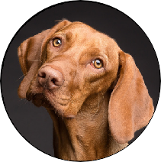

Name Phone Address Email

Avery Davis

+123-456-7890

123 Anywhere St., Any City [info@caratulas.de](mailto:info@caratulas.de)